Given the following set of information, find a linear equation satisfying the conditions, if possible:
Passes through (5, 1) and (3, −9)
Select one:
y=5x+3y=5x+3
y=5x−5y=5x−5
y=5x−24y=5x−24
y=5x−1y=5x−1

A town’s population increases at a constant rate. In 2010 the population was 65,000. By 2012 the population had increased to 90,000. Assuming this trend continues, predict the population in 2018.
Select one:
102,500
165,000
127,500

Does Table 1 represent a linear function? If so, find a linear equation that models the data.

Table 1
x | -6 | 0 | 2 | 4
g(x) | 14 | 32 | 38 | 44

Select one:
no, it's exponential
yes, g(x)=3x+32g(x)=3x+32
yes, g(x)=3x−6g(x)=3x−6

Determine whether the lines given by the equations below are parallel, perpendicular, or neither parallel nor perpendicular:
−2x+y=3−2x+y=3
3x+32y=53x+32y=5
Select one:
parallel
perpendicular
neither

Y=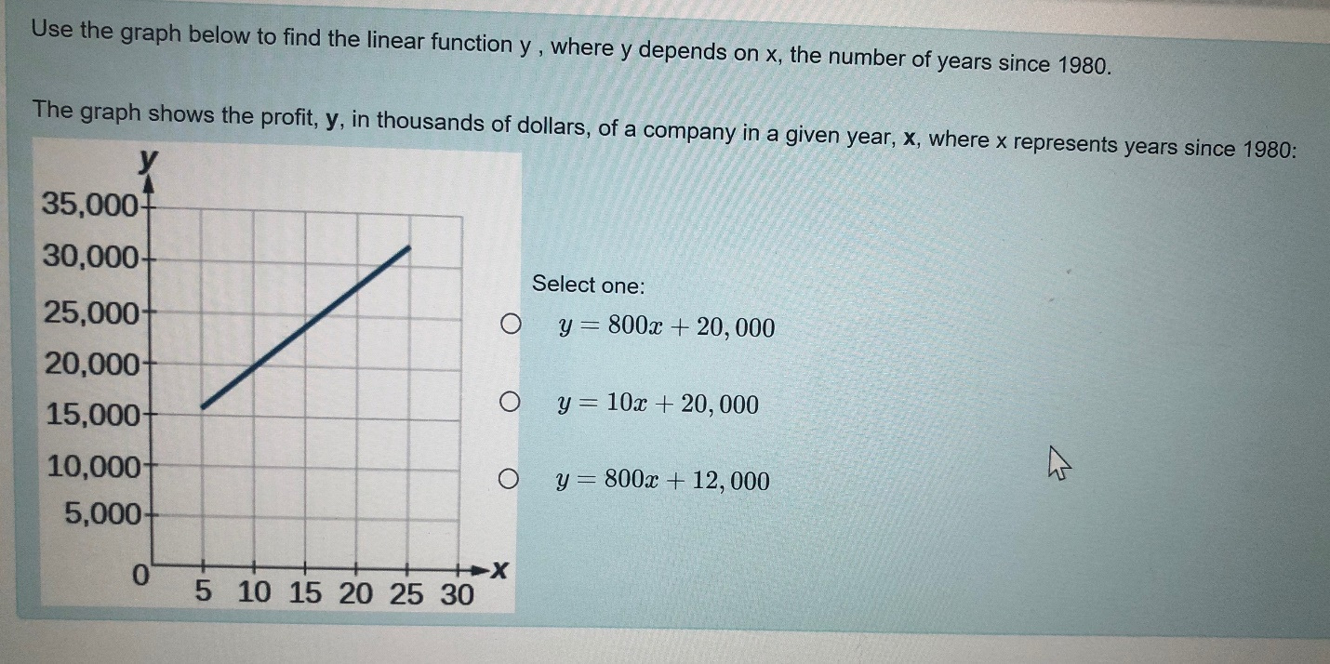
y=800x+12000

